DEPARTMENT OF COMPUTER SCIENCE AND ENGINEERING

INSTITUTE OF ENGINEERING AND TECHNOLOGY, LUCKNOW PRACTICAL FILE : OBJECT ORIENTED PROGRAMMING

ICS-452

SESSION-2024-25

COURSE- B.TECH

COMPUTER SCIENCE AND ENGINEERING (ARTIFICIAL INTELLIGENCE)

SUBMITTED TO **: Dr.SAKSHI SRIVASTAVA**

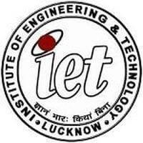

**Mr.Hanuman Maurya Ms.Srishti Tiwari**

SUBMITTED BY :

ROLL N0. : 23005215200

DATE: